**Vaccinations**

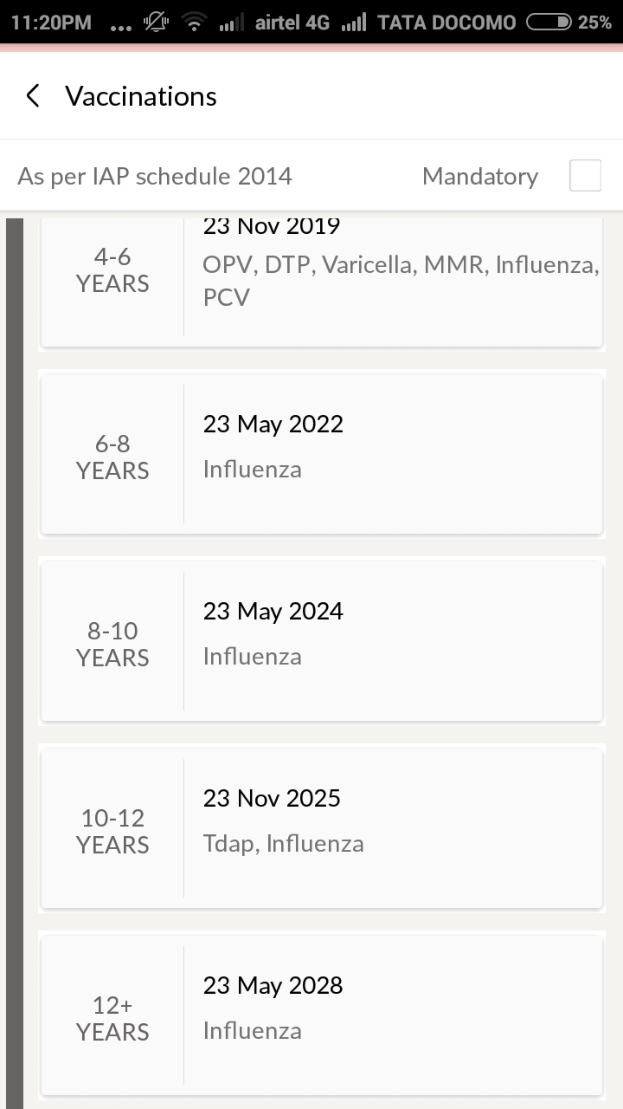

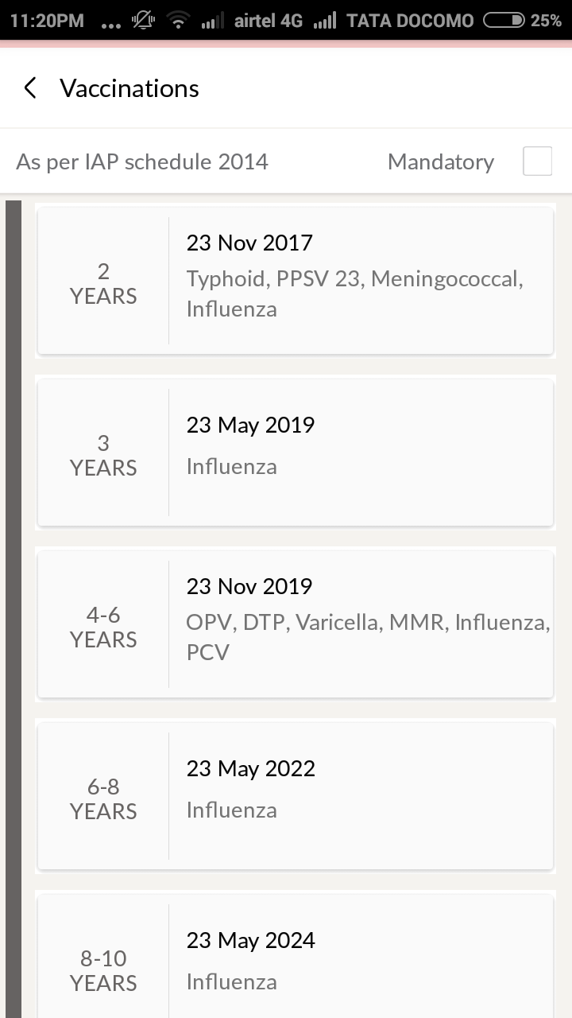

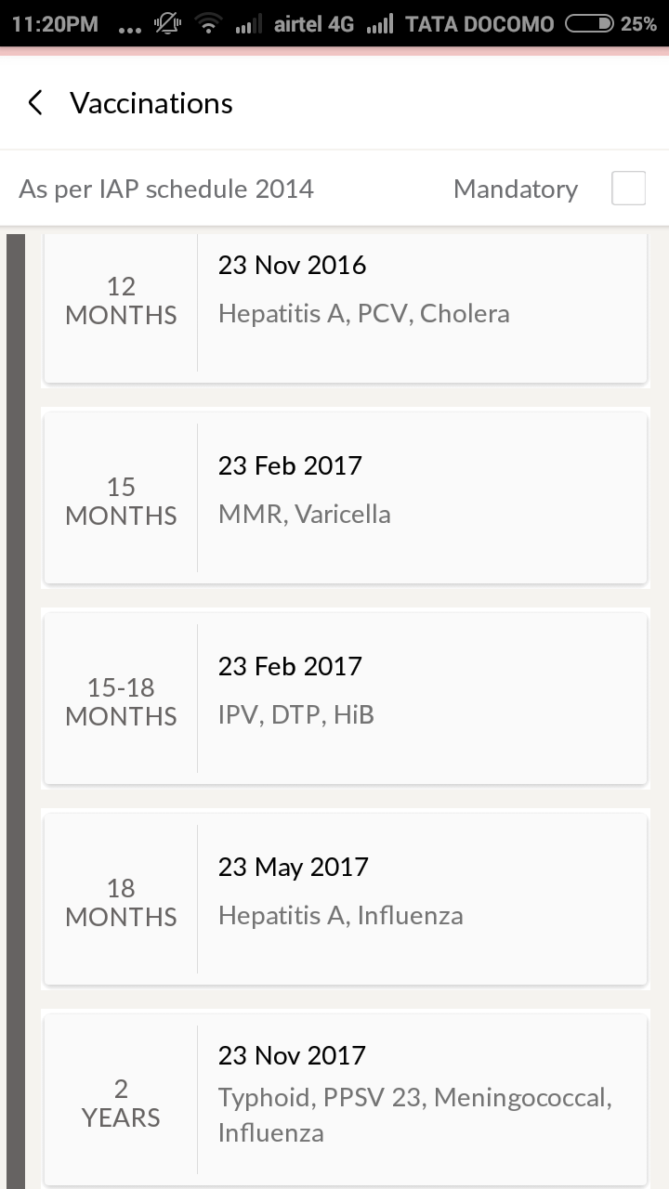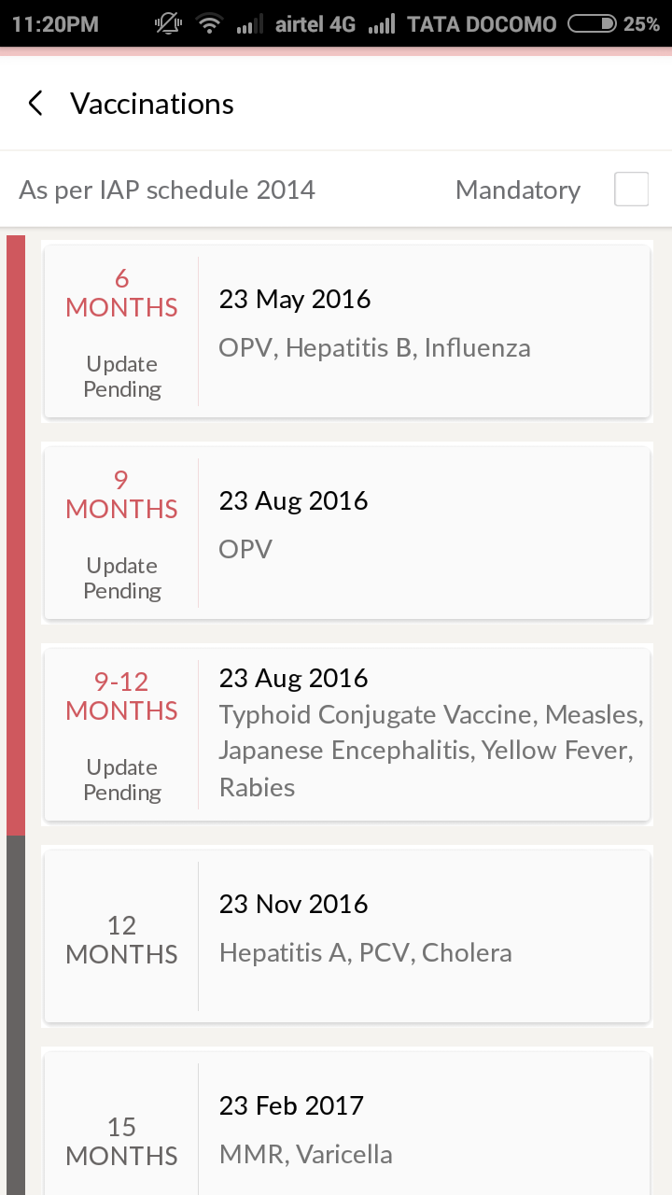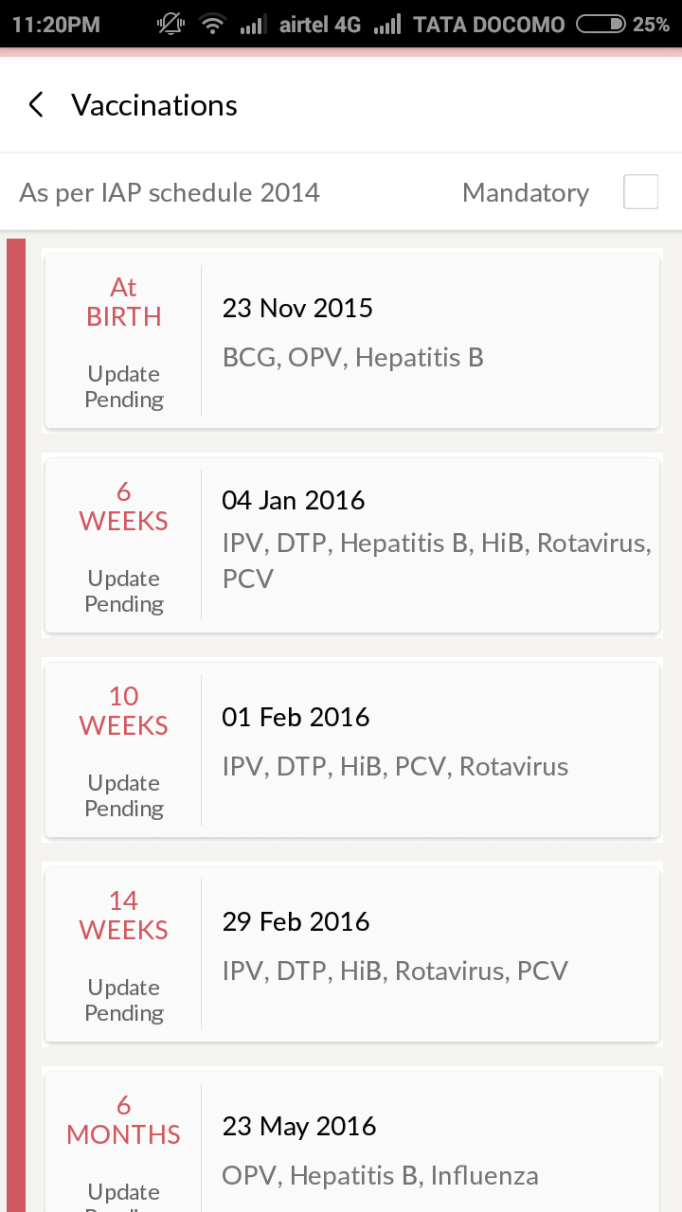

BABY ORODUCTS

MEDICAL TESTS

Common Tests During Pregnancy

The following are some of the more common tests performed during pregnancy:

**First Trimester Prenatal Screening Tests**

First trimester screening is a combination of fetal ultrasound and maternal blood testing performed during the first trimester of pregnancy. This screening process can help to determine the risk of the fetus having certain birth defects. Screening tests may be used alone or in combination with other tests.

There are three parts of first trimester screening:

* **Ultrasound test for fetal nuchal translucency (NT).**Nuchal translucency screening uses an ultrasound test to examine the area at the back of the fetal neck for increased fluid or thickening.
* **Two maternal serum (blood) tests.**The blood tests measure two substances found in the blood of all pregnant women:
  + **Pregnancy-associated plasma protein screening (PAPP-A)**--a protein produced by the placenta in early pregnancy. Abnormal levels are associated with an increased risk for chromosome abnormality.
  + **Human chorionic gonadotropin (hCG)**--a hormone produced by the placenta in early pregnancy. Abnormal levels are associated with an increased risk for chromosome abnormality.

When used together as first trimester screening tests, nuchal translucency screening and maternal blood tests have a greater ability to determine if the fetus might have a birth defect, such as Down syndrome (trisomy 21) and trisomy 18.

If the results of these first trimester screening tests are abnormal, genetic counseling is recommended. Additional testing such as chorionic villus sampling, amniocentesis, cell-free fetal DNA, or other ultrasounds may be needed for accurate diagnosis.

**Second Trimester Prenatal Screening Tests**

Second trimester prenatal screening may include several blood tests, called multiple markers.  These markers provide information about a woman's risk of having a baby with certain genetic conditions or birth defects. Screening is usually performed by taking a sample of the mother's blood between the 15th and 20th weeks of pregnancy (16th to 18th is ideal). The multiple markers include:

* **Alpha-fetoprotein screening (AFP).**This blood test measures the level of alpha-fetoprotein in the mothers' blood during pregnancy. AFP is a protein normally produced by the fetal liver and is present in the fluid surrounding the fetus (amniotic fluid), and crosses the placenta into the mother's blood. The AFP blood test is also called MSAFP (maternal serum AFP).  
    
  Abnormal levels of AFP may signal the following:
  + Open neural tube defects (ONTD), such as spina bifida
  + Down syndrome
  + Other chromosomal abnormalities
  + Defects in the abdominal wall of the fetus
  + Twins--more than one fetus is making the protein
  + A miscalculated due date, as the levels vary throughout pregnancy
* **hCG.**This is human chorionic gonadotropin hormone (a hormone produced by the placenta)
* **Estriol.**This is a  hormone produced by the placenta
* **Inhibin.**This is a hormone produced by the placenta

Abnormal test results of AFP and other markers may indicate the need for additional testing. Usually an ultrasound is performed to confirm the dates of the pregnancy and to look at the fetal spine and other body parts for defects. An amniocentesis may be needed for accurate diagnosis.

Multiple marker screening is not diagnostic. This means it is not 100 percent accurate, and is only a screening test to determine who in the population should be offered additional testing for their pregnancy. There can be false-positive results--indicating a problem when the fetus is actually healthy or false negative results--indicating a normal result when the fetus actually does have a health problem.

When a woman has both first and second trimester screening tests performed, the ability of the tests to detect an abnormality is greater than using just one screening independently.  Nearly all cases of Down Syndrome can be detected when both first and second trimester screening are used.

**What is an amniocentesis?**

An amniocentesis is a procedure used to obtain a small sample of the amniotic fluid that surrounds the fetus to diagnose chromosomal disorders and open neural tube defects (ONTDs), such as spina bifida. Testing is available for other genetic defects and disorders depending on the family history and availability of laboratory testing at the time of the procedure. An amniocentesis is generally offered to women between the 15th and 20th weeks of pregnancy who are at increased risk for chromosome abnormalities, such as women who are over age 35 years of age at delivery, or those who have had an abnormal maternal serum screening test, indicating an increased risk for a chromosomal abnormality or neural tube defect.

Click Image to Enlarge

**How is an amniocentesis performed?**

An amniocentesis is a procedure that involves inserting a long, thin needle through the mother's abdomen into the amniotic sac to withdraw a small sample of the amniotic fluid for examination. The amniotic fluid contains cells shed by the fetus, which contain genetic information. Although specific details of each procedure vary slightly, generally, an amniocentesis follows this process:

* The woman's abdomen is cleansed with an antiseptic.
* The doctor may or may not give a local anesthetic to numb the skin.
* Ultrasound is used to help guide a hollow needle into the amniotic sac.
* A small sample of fluid is withdrawn for laboratory analysis.
* Strenuous activities should be avoided for 24 hours following an amniocentesis.
* Women may feel some cramping during or after the amniocentesis.

Women with twins or other multiples need sampling from each amniotic sac, in order to study each baby. Depending on the position of the baby, placenta, amount of fluid, or patient's anatomy, sometimes the amniocentesis cannot be performed. The fluid is sent to a genetics laboratory so that the cells can grow and be analyzed. Alpha-fetoprotein, a protein made by the fetus that is present in the fluid, is also measured to rule out an open neural tube defect, such as spina bifida. Results are usually available in about 10 days to two weeks, depending on the laboratory.

**What is a chorionic villus sampling (CVS)?**

Chorionic villus sampling (CVS) is a prenatal test that involves taking a sample of some of the placental tissue. This tissue contains the same genetic material as the fetus and can be tested for chromosomal abnormalities and some other genetic problems. Testing is available for other genetic defects and disorders depending on the family history and availability of laboratory testing at the time of the procedure. In comparison to amniocentesis (another type of prenatal test), CVS does not provide information on neural tube defects such as spina bifida. For this reason, women who undergo CVS also need a follow-up blood test between 16 to 18 weeks of their pregnancy, to screen for neural tube defects.

Click Image to Enlarge

**How is CVS performed?**

CVS may be offered to women who are at increased risk for chromosomal abnormalities or have a family history of a genetic defect that is testable from the placental tissue. CVS is usually performed between the 10th and 12th weeks of pregnancy. Although exact methods can vary, the procedure involves inserting a small tube called a catheter through a woman's vagina and into her cervix and usually follows this process:

* Ultrasound is used to guide the catheter into place near the placenta.
* Tissue is removed using a syringe on the other end of the catheter.
* Another method is transabdominal CVS, which involves inserting a needle through the woman's abdomen and into her uterus to sample the placental cells.
* Women may feel some cramping during and after the CVS procedure.
* The tissue samples are sent to a genetic laboratory to grow and be analyzed. Results are usually available in about 10 days to two weeks, depending on the laboratory.

Women with twins or other multiples usually need sampling from each placenta. However, because of the complexity of the procedure, and positioning of the placentas, CVS is not always feasible or successful with multiples.

Some women may not be candidates for CVS or may not obtain results that are 100 percent accurate, and may therefore require a follow-up amniocentesis. In some cases there is an active vaginal infection, such as herpes or gonorrhea, which will prohibit the procedure. Other times the doctor obtains a sample that does not have enough tissue to grow in the laboratory, such that results are incomplete or inconclusive.

**What is fetal monitoring?**

During late pregnancy and during labor, your doctor may want to monitor the fetal heart rate and other functions. Fetal heart rate monitoring is a method of checking the rate and rhythm of the fetal heartbeat. The average fetal heart rate is between 110 and 160 beats per minute. The fetal heart rate may change as the fetus responds to conditions in the uterus. An abnormal fetal heart rate or pattern may mean that the fetus is not getting enough oxygen or there are other problems. An abnormal pattern also may mean that an emergency or cesarean delivery is needed.

**How is fetal monitoring performed?**

Using a fetoscope (a type of stethoscope) to listen to the fetal heart beat is the most basic type of fetal heart rate monitoring. Another type of monitoring is with a hand held Doppler device. This is often used during prenatal visits to count the fetal heart rate. During labor, continuous electronic fetal monitoring is often used. Although the specific details of each procedure vary slightly, generally, electronic fetal monitoring follows this process:

* Gel is applied to the mother's abdomen to act as a medium for the ultrasound transducer.
* The ultrasound transducer is attached to the abdomen with straps and transmits the fetal heartbeat to a recorder. The fetal heart rate is displayed on a screen and printed onto special paper.
* During contractions, an external tocodynamometer (a monitoring device that is placed over the top of the uterus with a belt) can record the patterns of contractions.
* Sometimes, internal fetal monitoring is necessary for a more accurate reading of the fetal heart rate. Your bag of waters (amniotic fluid) must be broken and your cervix must be partially dilated to use internal monitoring. Internal fetal monitoring involves inserting an electrode through the dilated cervix and attaching the electrode to the scalp of the fetus, called a fetal scalp electrode.

**What are a glucose challenge and a glucose tolerance tests?**

The initial 1-hour test is a glucose challenge test. If the results are abnormal, a glucose tolerance test is done.

A glucose tolerance test, usually conducted in the 24 to 28 weeks of pregnancy, measures levels of sugar (glucose) in the mother's blood. Abnormal glucose levels may indicate gestational diabetes.

**How is a glucose tolerance test performed?**

The glucose tolerance test is done if the woman has an elevated 1-hour glucose challenge test.

Although the specific details of each procedure vary slightly, generally, a glucose tolerance test follows this process:

* The mother-to-be may be asked to only drink water on the day the glucose tolerance test is given.
* An initial fasting sample of blood is drawn from a vein.
* You will be given a special glucose solution to drink.
* Blood will be drawn several times over the course of several hours to measure the glucose levels in your body.

**What is a Group B strep culture?**

Group B Streptococcus (GBS) are bacteria found in the lower genital tract of about 25 percent of all women. GBS infection usually causes no problems in women before pregnancy, but can cause serious illness in the mother during pregnancy. GBS may cause chorioamnionitis (a severe infection of the placental tissues) and postpartum infection. Urinary tract infections caused by GBS can lead to preterm labor and birth, or pyelonephritis and sepsis.

GBS is the most common cause of life-threatening infections in newborns, including pneumonia and meningitis. Newborn babies contract the infection during pregnancy or from the mother's genital tract during labor and delivery.

The Centers for Disease Control and Prevention recommends screening of all pregnant women for vaginal and rectal group B strep colonization between 35 to 37 weeks' gestation. Treatment of mothers with certain risk factors or positive cultures is important to reduce the risk of transmission of GBS to the baby. Babies whose mothers receive antibiotic treatment for a positive GBS test are 20 times less likely to develop the disease than those without treatment.

**What is an ultrasound?**

An ultrasound scan is a diagnostic technique which uses high-frequency sound  
waves to create an image of the internal organs. A screening ultrasound is sometimes done during the course of a pregnancy to check normal fetal growth and verify the due date. Ultrasounds may be performed at various times throughout pregnancy for different reasons:

**In the first trimester**

* To establish the dates of a pregnancy
* To determine the number of fetuses and identify placental structures
* To diagnose an ectopic pregnancy or miscarriage
* To examine the uterus and other pelvic anatomy
* In some cases to detect fetal abnormalities

**Mid-trimester** (sometimes called the 18 to 20 week scan)

* To confirm pregnancy dates
* To determine the number of fetuses and examine the placental structures
* To assist in prenatal tests, such as an amniocentesis
* To examine the fetal anatomy for presence of abnormalities
* To check the amount of amniotic fluid
* To examine blood flow patterns
* To observe fetal behavior and activity
* To examine the placenta
* To measure the length of the cervix
* To monitor fetal growth

**Third trimester**

* To monitor fetal growth
* To check the amount of amniotic fluid
* As part of the biophysical profile
* To determine the position of a fetus
* To assess the placenta

**How is an ultrasound scan performed?**

Although the specific details of each procedure vary slightly, generally, ultrasounds follow this process. Two types of ultrasounds can be performed during pregnancy:

* **Abdominal ultrasound**   
  In an abdominal ultrasound, gel is applied to the abdomen and the ultrasound transducer glides over the gel on the abdomen to create the image.
* **Transvaginal ultrasound**   
  In a transvaginal ultrasound, a smaller ultrasound transducer is inserted into the vagina and rests against the back of the vagina to create an image. A transvaginal ultrasound produces a sharper image and is often used in early pregnancy.

There are several types of ultrasound imaging techniques. The most common is two dimensional, or 2D. This gives a flat picture of one aspect of the image.

If more information is needed, a 3D ultrasound examination can be performed. This technique, which provides a three-dimensional picture, requires a special machine and special training. But the 3D image allows the health care provider to see width, height, and depth of images, which can be helpful in diagnosis. The 3D images can also be captured and saved for later review.

The latest technology is 4D ultrasound, which allows the health care provider to visualize the unborn baby moving in real-time. With 4D imaging, a three-dimensional image is continuously updated, providing a "live action" view. These images often have a golden color, which helps show shadows and highlights.

Ultrasound images may be captured in still photographs or on video to document findings.

Ultrasound is a technique that is constantly being improved and refined. As with any test, results may not be completely accurate. However, ultrasound can provide valuable information for parents and health care providers to help manage and care for the pregnancy and fetus. In addition, ultrasound gives parents a unique opportunity to see their baby before birth, helping them to bond and establish an early relationship.

**What are the risks and benefits of ultrasound?**

Fetal ultrasound has no known risks other than mild discomfort due to pressure from the transducer on the abdomen or in the vagina. No radiation is used during the procedure.

Transvaginal ultrasound requires covering the ultrasound transducer in a plastic/latex sheath, which may cause a reaction in patients with a latex allergy.

Fetal ultrasound is sometimes offered in nonmedical settings to provide keepsake images or videos for parents. While the ultrasound procedure itself is considered safe, it is possible that untrained personnel may give parents false assurances about their baby's well-being, or perhaps an abnormality may be missed. Having ultrasound performed by trained medical personnel who can correctly interpret findings is recommended. Talk with your doctor or midwife if you have questions.

**What is genetic screening?**

Many genetic abnormalities can be diagnosed before birth. Your doctor or midwife may recommend genetic testing during the pregnancy if you or your partner have a family history of genetic disorders and/or you have had a fetus or baby with a genetic abnormality.

Examples of genetic disorders that can be diagnosed before birth include the following:

* Cystic fibrosis
* Duchenne muscular dystrophy
* Hemophilia A
* Thalassemia
* Sickle cell anemia
* Polycystic kidney disease
* Tay-Sachs disease

**What do genetic screening methods include?**

Genetic screening methods may include the following:

* Ultrasound scan
* Alpha-fetoprotein test (AFP) or multiple marker test
* Chorionic villus sampling (CVS)
* Amniocentesis
* Percutaneous umbilical blood sampling (withdrawing a small sample of the fetal blood from the umbilical cord)

Common Tests During Pregnancy

The following are some of the more common tests done during pregnancy:

First trimester prenatal screening tests

First trimester screening is a combination of fetal ultrasound and maternal blood testing. This screening process can help to determine the risk of the fetus having certain birth defects. Screening tests may be used alone or  with other tests.

There are 3 parts of first trimester screening:

* **Ultrasound test for fetal nuchal translucency (NT).**Nuchal translucency screening uses an ultrasound test to examine the area at the back of the fetal neck for increased fluid or thickening.
* **Two maternal serum (blood) tests.**The blood tests measure 2 substances found in the blood of all pregnant women:
  + **Pregnancy-associated plasma protein screening (PAPP-A)**--a protein produced by the placenta in early pregnancy. Abnormal levels are associated with an increased risk for chromosome abnormality.
  + **Human chorionic gonadotropin (hCG)**--a hormone produced by the placenta in early pregnancy. Abnormal levels are associated with an increased risk for chromosome abnormality.

When used together as first trimester screening tests, nuchal translucency screening and maternal blood tests have a greater ability to determine if the fetus might have a birth defect, such as Down syndrome (trisomy 21) and trisomy 18.

If the results of these first trimester screening tests are abnormal, genetic counseling is recommended. More testing such as chorionic villus sampling, amniocentesis, cell-free fetal DNA, or other ultrasounds may be needed for accurate diagnosis.

Second trimester prenatal screening tests

Second trimester prenatal screening may include several blood tests, called multiple markers.  These markers give information about a woman's risk of having a baby with certain genetic conditions or birth defects. Screening is usually done by taking a sample of the mother's blood between the 15th and 20th weeks of pregnancy (16th to 18th is ideal). The multiple markers include:

* **Alpha-fetoprotein screening (AFP).**This blood test measures the level of alpha-fetoprotein in the mothers' blood during pregnancy. AFP is a protein normally produced by the fetal liver and is present in the fluid surrounding the fetus (amniotic fluid), and crosses the placenta into the mother's blood. The AFP blood test is also called MSAFP (maternal serum AFP).  
    
  Abnormal levels of AFP may signal:
  + Open neural tube defects (ONTD), such as spina bifida
  + Down syndrome
  + Other chromosomal abnormalities
  + Defects in the abdominal wall of the fetus
  + Twins--more than one fetus is making the protein
  + A miscalculated due date, as the levels vary throughout pregnancy
* **hCG.**This is human chorionic gonadotropin hormone (a hormone produced by the placenta).
* **Estriol.**This is a  hormone produced by the placenta.
* **Inhibin.**This is a hormone produced by the placenta.

Abnormal test results of AFP and other markers may mean more testing is needed. Usually an ultrasound is done to confirm the dates of the pregnancy and to look at the fetal spine and other body parts for defects. An amniocentesis may be needed for accurate diagnosis.

Multiple marker screening is not diagnostic. This means it is not 100% accurate, and is only a screening test to determine who in the population should be offered more testing for their pregnancy. There can be false-positive results--indicating a problem when the fetus is actually healthy or false negative results--indicating a normal result when the fetus actually does have a health problem.

When a woman has both first and second trimester screening tests done, the ability of the tests to detect an abnormality is greater than using just one screening independently.  Nearly all cases of Down Syndrome can be detected when both first and second trimester screening are used.

What is an amniocentesis?

An amniocentesis is a procedure used to take a small sample of the amniotic fluid that surrounds the fetus. It is done to diagnose chromosomal disorders and open neural tube defects (ONTDs), such as spina bifida. Testing is available for other genetic defects and disorders depending on the family history and availability of lab testing at the time of the procedure. An amniocentesis is generally offered to women between the 15th and 20th weeks of pregnancy who are at increased risk for chromosome abnormalities, such as women who are over age 35 years of age at delivery, or those who have had an abnormal maternal serum screening test, indicating an increased risk for a chromosomal abnormality or neural tube defect.

Click Image to Enlarge

How is an amniocentesis done?

An amniocentesis involves inserting a long, thin needle through the mother's abdomen into the amniotic sac to withdraw a small sample of the amniotic fluid for examination. The amniotic fluid contains cells shed by the fetus, which contain genetic information. Although specific details of each procedure vary slightly, generally, an amniocentesis follows this process:

* The woman's abdomen is cleansed with an antiseptic.
* The doctor may or may not give a local anesthetic to numb the skin.
* Ultrasound is used to help guide a hollow needle into the amniotic sac.
* A small sample of fluid is withdrawn for lab analysis.
* Strenuous activities should be avoided for 24 hours following an amniocentesis.
* Women may feel some cramping during or after the amniocentesis.

Women with twins or other multiples need sampling from each amniotic sac, to study each baby. Depending on the position of the baby, placenta, amount of fluid, or patient's anatomy, sometimes the amniocentesis cannot be done. The fluid is sent to a genetics lab so that the cells can grow and be analyzed. Alpha-fetoprotein, a protein made by the fetus that is present in the fluid, is also measured to rule out an open neural tube defect, such as spina bifida. Results are usually available in about 10 days to 2 weeks, depending on the lab.

What is a chorionic villus sampling (CVS)?

Chorionic villus sampling (CVS) is a prenatal test that involves taking a sample of some of the placental tissue. This tissue contains the same genetic material as the fetus and can be tested for chromosomal abnormalities and some other genetic problems. Testing is available for other genetic defects and disorders depending on the family history and availability of lab testing at the time of the procedure. Unlike amniocentesis (another type of prenatal test), CVS does not provide information on neural tube defects such as spina bifida. For this reason, women who undergo CVS also need a follow-up blood test between 16 to 18 weeks of their pregnancy, to screen for neural tube defects.

Click Image to Enlarge

How is CVS done?

CVS may be offered to women who are at increased risk for chromosomal abnormalities or have a family history of a genetic defect that is testable from the placental tissue. CVS is usually done between the 10th and 13th weeks of pregnancy. Although exact methods can vary, the procedure involves inserting a small tube called a catheter through a woman's vagina and into her cervix and usually follows this process:

* Ultrasound is used to guide the catheter into place near the placenta.
* Tissue is removed using a syringe on the other end of the catheter.
* Another method is transabdominal CVS, which involves inserting a needle through the woman's abdomen and into her uterus to sample the placental cells.
* Women may feel some cramping during and after the CVS procedure.
* The tissue samples are sent to a genetic lab to grow and be analyzed. Results are usually available in about 10 days to 2 weeks, depending on the lab.

Women with twins or other multiples usually need sampling from each placenta. However, because of the complexity of the procedure, and positioning of the placentas, CVS is not always feasible or successful with multiples.

Some women may not be candidates for CVS or may not get results that are 100% accurate, and may therefore require a follow-up amniocentesis. In some cases there is an active vaginal infection, such as herpes or gonorrhea, which will prohibit the procedure. Other times the doctor takes a sample that does not have enough tissue to grow in the lab, such that results are incomplete or inconclusive.

What is fetal monitoring?

During late pregnancy and during labor, your doctor may want to monitor the fetal heart rate and other functions. Fetal heart rate monitoring is a method of checking the rate and rhythm of the fetal heartbeat. The average fetal heart rate is between 110 and 160 beats per minute. The fetal heart rate may change as the fetus responds to conditions in the uterus. An abnormal fetal heart rate or pattern may mean that the fetus is not getting enough oxygen or there are other problems. An abnormal pattern also may mean that an emergency or cesarean delivery is needed.

How is fetal monitoring done?

Using a fetoscope (a type of stethoscope) to listen to the fetal heart beat is the most basic type of fetal heart rate monitoring. Another type of monitoring is with a hand held Doppler device. This is often used during prenatal visits to count the fetal heart rate. During labor, continuous electronic fetal monitoring is often used. Although the specific details of each procedure vary slightly, generally, electronic fetal monitoring follows this process:

* Gel is applied to the mother's abdomen to act as a medium for the ultrasound transducer.
* The ultrasound transducer is attached to the abdomen with straps and transmits the fetal heartbeat to a recorder. The fetal heart rate is displayed on a screen and printed onto special paper.
* During contractions, an external tocodynamometer (a monitoring device that is placed over the top of the uterus with a belt) can record the patterns of contractions.
* Sometimes, internal fetal monitoring is needed for a more accurate reading of the fetal heart rate. Your bag of waters (amniotic fluid) must be broken and your cervix must be partially dilated to use internal monitoring. Internal fetal monitoring involves inserting an electrode through the dilated cervix and attaching the electrode to the scalp of the fetus, called a fetal scalp electrode.

What are a glucose challenge and a glucose tolerance tests?

The initial 1-hour test is a glucose challenge test. If the results are abnormal, a glucose tolerance test is done.

A glucose tolerance test, usually conducted in the 24 to 28 weeks of pregnancy, measures levels of sugar (glucose) in the mother's blood. Abnormal glucose levels may indicate gestational diabetes.

How is a glucose tolerance test done?

The glucose tolerance test is done if the woman has an elevated 1-hour glucose challenge test.

Although the specific details of each procedure vary slightly, generally, a glucose tolerance test follows this process:

* The mother-to-be may be asked to only drink water on the day the glucose tolerance test is given.
* An initial fasting sample of blood is drawn from a vein.
* You will be given a special glucose solution to drink.
* Blood will be drawn several times over the course of several hours to measure the glucose levels in your body.

What is a Group B strep culture?

Group B Streptococcus (GBS) are bacteria found in the lower genital tract of about 25% of all women. GBS infection usually causes no problems in women before pregnancy, but can cause serious illness in the mother during pregnancy. GBS may cause chorioamnionitis (a severe infection of the placental tissues) and postpartum infection. Urinary tract infections caused by GBS can lead to preterm labor and birth, or pyelonephritis and sepsis.

GBS is the most common cause of life-threatening infections in newborns, including pneumonia and meningitis. Newborn babies contract the infection during pregnancy or from the mother's genital tract during labor and delivery.

The Centers for Disease Control and Prevention recommends screening of all pregnant women for vaginal and rectal group B strep colonization between 35 to 37 weeks' gestation. Treatment of mothers with certain risk factors or positive cultures is important to reduce the risk of transmission of GBS to the baby. Babies whose mothers receive antibiotic treatment for a positive GBS test are 20 times less likely to develop the disease than those without treatment.

What is an ultrasound?

An ultrasound scan is a diagnostic technique which uses high-frequency sound  
waves to create an image of the internal organs. A screening ultrasound is sometimes done during the course of a pregnancy to check normal fetal growth and verify the due date. Ultrasounds may be done at various times throughout pregnancy for different reasons:

**In the first trimester**

* To establish the due date -- this is the most accurate way of determining the due date
* To determine the number of fetuses and identify placental structures
* To diagnose an ectopic pregnancy or miscarriage
* To examine the uterus and other pelvic anatomy
* In some cases to detect fetal abnormalities

**Mid-trimester** (sometimes called the 18 to 20 week scan)

* To confirm the due date -- a due date set in the first trimester is rarely changed
* To determine the number of fetuses and examine the placental structures
* To assist in prenatal tests, such as an amniocentesis
* To examine the fetal anatomy for presence of abnormalities
* To check the amount of amniotic fluid
* To examine blood flow patterns
* To observe fetal behavior and activity
* To examine the placenta
* To measure the length of the cervix
* To monitor fetal growth

**Third trimester**

* To monitor fetal growth
* To check the amount of amniotic fluid
* As part of the biophysical profile
* To determine the position of a fetus
* To assess the placenta

**Routine tests**

**What diseases are regularly tested for even during a normal pregnancy**

Some of the conditions routinely checked for in most normal pregnancies are Aids, Hepatitis B, Down's Syndrome, Neural Tube Defects, Rh Incompatibility and Rubella.  The doctor can test for all these condition with blood samples, albeit taken at different times in the pregnancy.

**When should I be worried about congenital diseases**

Your baby has a higher chance of having congenital disease if he falls in any of the three reasons given below.  Note that there could be many other reasons for congenital diseases also.

* Congenital diseases in the previous baby
* History of congenital anomalies in the family which are likely to be repeated
* Maternal age is above 35, then there is a higher chance of the baby getting Down's syndrome

**Can birth defects be detected with regular blood tests**

Studies have shown that 90 % of birth defects cannot be detected through prenatal blood tests. In order to isolate the remaining 10 % of the identifiable birth defects, there are four main types of tests: amniocentesis, chorionic villi sampling, certain blood tests like the Alphafeto-Protein (AFP) test, and ultrasound scans.

**What do each of the diagnostic tests tell the doctor**

There are various conditions or diseases that a doctor can identify by conducting different diagnostic tests during the pregnancy. These tests can indicate the possibility of birth defects in the foetus or conditions in the mother's health that may lead to problem pregnancies. Once any potential problem has been identified, appropriate steps can be taken to deal with it.

|  |  |
| --- | --- |
| **Diagnostic test** | **Possible Findings** |
|  |  |
| Regular blood test | Confirmation of pregnancy (hCG hormone), blood group and Rh- disease, heamoglobin levels, platelet count |
| AIDS blood test | AIDS |
| Hepatitis B blood test | Hepatitis B |
| Rubella blood test | Rubella (German Measles) |
| Alphafeto-protein (AFP) blood test | Neural Tube Defects (NTD) |
| Urine Test | Confirmation of pregnancy (hCG hormone), sugar, albumin, bacteria |
| Sonogram (Ultrasound Scan) | Genetic deformities (including Down's syndrome) |
| Amniocentesis | Spina bifida (Open Spine), Anencephaly (Failure of brain formation), Down's syndrome |
| Chorionic Villi Sampling (CVS) | Tay-Sachs, sickle-cell anaemia, Down's syndrome, thalassaemia |